EECS371 Design Project #9

Triacs and AC Phase Control

Review the course BB documents on “Triacs”. (It is not necessary to review the “solid-state” concepts.)

1. TRIAC Static Characteristics
A) Using a BT139 triac connected to a DC bench supply, measure and record the approximate trigger current, Igt, of the triac in each quadrant. Use the 2 amp, 12-volt lamp as a load. Remember that the triac will trigger on extremely short pulses (from “pot- wiper bounce”, for example), so you might want to place a large cap (100 μFd) from gate to ground and use a smoothly-variable bench voltage-source and a series gate resistor instead of a pot to generate variable gate current.

B) Measure and record the holding current, I_{H,} and latching current, I_{L}, of this triac. Again, beware of pot-wiper bounce; use a bench voltage supply and a fixed resistor to set main-terminal current.

2. Lamp Dimmer
A) Design and build a phase-control lamp dimmer to drive a 12V, 2A lamp with AC. Use the secondary of the transformer from the “3 Amp 12V” power supply as the power supply; your circuit is to be self-contained, and a separate power supply is not to be used for the control circuitry. Record traces of lamp current and voltage at several conduction angles. You may use a 0.1-ohm resistor or a current probe to view triac current.

Your phase-control dimmer will smoothly control the lamp from OFF to ON, using a 0 to 1 VDC control voltage as supplied from a bench supply. You must have at least 330 degrees of conduction. Measure and record the maximum ON phase angle. The conduction angle should be nominally proportional to the DC input voltage.

B) Add a “soft-start” feature so, at any DC control voltage, the lamp slowly ramps to the desired brightness setting (as set by the control voltage) over a ~2 second period upon the application of AC power. The lamp will, however, respond quickly to changes in control voltage. (The soft-start function should not apply to the DC control voltage). The “soft-start” circuit will reset with an AC power dropout of greater than 1 second. Assume that the DC control voltage will remain applied during the time that the AC power is off.

Define a dropout as a dip in line voltage to below about 95VAC. Be careful to keep the reset time of the circuit short (<< 1 second) so that it can respond to fast power-line on/off cycles. Important: review the paper on “soft-start circuitry” on BB.

Note: Remember that the period when the triac is ON may sometimes be used to sync your phase-angle delay (along with the zero-crossing detector). Check the standard dimmer circuits.

C) Add a "front end" to the control input of your dimmer circuit that will accept a 0 to 5 V square wave from a function generator. Configure your circuit so that the phase angle will vary linearly from zero to 330 deg. (nominal) as the frequency of the generator is changed from 1 kHz to 10 kHz. An input of 1 KHz should produce a phase angle of about zero; an input of 10KHz should provide a phase angle of at least 330 deg. The end points (1 KHz and 10 KHz) should be accurate to +/- 5%.

3. Linearization
The phase delay (in degrees or time) provided by your circuit in part 2 will vary linearly as you change the input DC control voltage. However, the voltage (and thus the power) to the lamp will be extremely nonlinear. (See below). For example, the final 30° of conduction (out of 180°) will increase the power to the lamp by only about 3 %. In many applications, such as closed-loop motor control, this non-linearity can be a problem. Modify your circuit in 2-B above to provide a nominally linear power output vs input response. Keep built for the recitation. Hint: the phrase “ramp and pedestal”.

4. AC Output configuration
Provide a complete schematic showing how you would change the design in (3) to power the same load with FW rectified DC. It is not necessary to build this circuit, but be prepared to discuss your design.
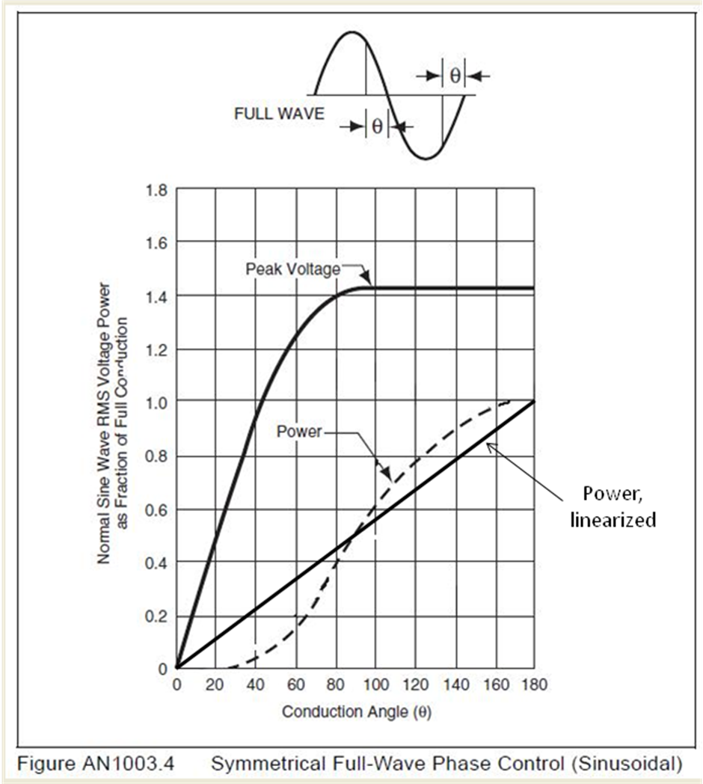
Note that the “power” curve shown above assumes a linear resistive load, such as a heater. An incandescent lamp will have a slightly different curve due to its non-linear resistance. If you are troubled by this you may replace the lamp with a resistor; 10 ohms or so would be OK for (3).

